Cabo Verde

## Political Stability Estimate Data

The data set shows the political stability estimate of the country each year.

## # A tibble: 19 x 5  
## country iso3c date stability stabilityCategory4  
## <chr> <chr> <dbl> <dbl> <chr>   
## 1 Cabo Verde CPV 1996 1.03 highly stable   
## 2 Cabo Verde CPV 1998 1.11 highly stable   
## 3 Cabo Verde CPV 2000 1.22 highly stable   
## 4 Cabo Verde CPV 2002 0.728 moderately stable   
## 5 Cabo Verde CPV 2003 0.919 moderately stable   
## 6 Cabo Verde CPV 2004 1.04 highly stable   
## 7 Cabo Verde CPV 2005 0.753 moderately stable   
## 8 Cabo Verde CPV 2006 0.963 moderately stable   
## 9 Cabo Verde CPV 2007 0.877 moderately stable   
## 10 Cabo Verde CPV 2008 0.813 moderately stable   
## 11 Cabo Verde CPV 2009 0.819 moderately stable   
## 12 Cabo Verde CPV 2010 0.841 moderately stable   
## 13 Cabo Verde CPV 2011 0.723 moderately stable   
## 14 Cabo Verde CPV 2012 0.809 moderately stable   
## 15 Cabo Verde CPV 2013 0.778 moderately stable   
## 16 Cabo Verde CPV 2014 0.351 moderately stable   
## 17 Cabo Verde CPV 2015 0.868 moderately stable   
## 18 Cabo Verde CPV 2016 0.886 moderately stable   
## 19 Cabo Verde CPV 2017 0.902 moderately stable

## Political Stability Estimate Plot

The plot shows the trends of stabilization and destabilization for the each country.

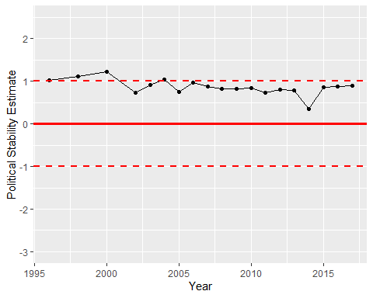

Political Stability Trend